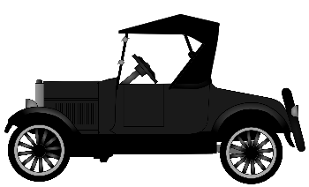
Fun Facts about Henry Ford and His Inventions WebQuest

Use the Internet to help you answer these questions. Click directly into the gray box to start typing your response. Upload to Google Classroom.

- What years did Henry Ford live?
- Where was Henry Ford born?
- Henry Ford was known as an industrialist. What does that term mean?
- What are two of the jobs that Ford did early in his career?
- Who is the well-known inventor that Ford worked for and who assisted him with his development of the automobile?
- Prior to the automobile, what similar device did Henry Ford design and build?
- Prior to Ford Motor Company, Henry Ford started another automobile company. What was its name?
- In what year did Henry Ford establish the Ford Motor Company?
- What was the first car that Ford introduced? In what year?
- What car did he introduce in 1908? What was its nickname?
- Approximately how many parts did that car have?
- What was that car’s selling price?
- In addition to his recognition for developing and innovating ideas for automobiles, what is the other innovation/invention Henry Ford was known for?
- How did the innovation mentioned in #12 make a difference for businesses?
- In 1914, Ford instituted a new way of paying workers. What was this and why was it important?

