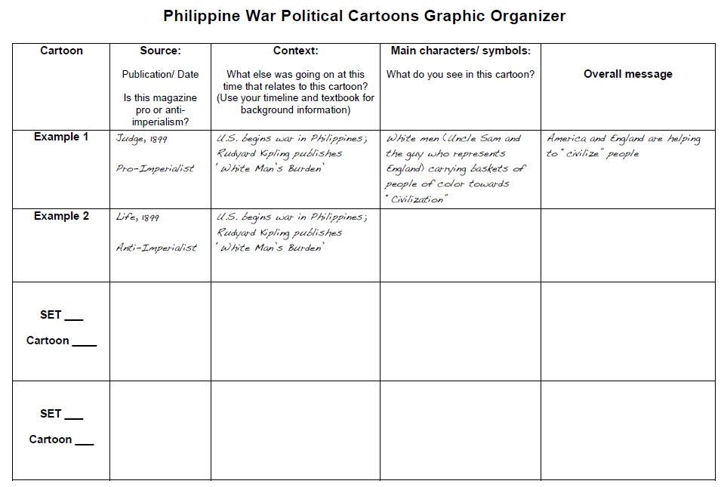

It is the duty of white people to bear the burden of civilizing inferior people.

White men Uncle Sam & the guy who represents England carrying baskets of people of color towards “Civilization”

US begins war in Philippines; Rudyard Kipling publishes “White Man’s Burden”

Judge, 1899sa

Pro-Imperialist

**Set C**

**Cartoon __**

**Set B**

**Cartoon __**

**Set A**

**Cartoon __**



**Set E**

**Cartoon __**

**Set F**

**Cartoon __**

**Set D**

**Cartoon __**