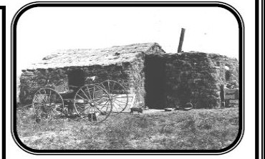

EXODUSTERS

In what year did African Americans start moving west? Where were they coming from?
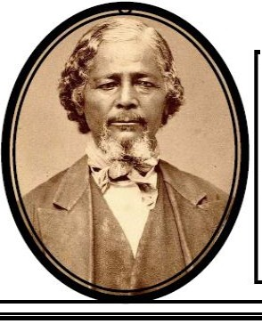What mode of transportation did they use to get west? List 2 Reasons African Americans went west:

Who is this?

What did he do?

Why did so many people go west to farm on the Great
Plains?

What were a few of the difficulties faced by farmers in the west?

List at least two inventions that made farming the Great
Plains easier. Please explain how they made farming easier.

How did the government encourage westward settlement and farming on the Great Plains?

What is this?

W hat does this tel l you about fa rm i ng on th e Grea t Pla ins?

BUFFALO SOLDIEilS

Who were the Buffalo Soldiers? What was their job in the west?
How do you think Buffalo Soldiers viewed Native Ameri­
cans In the west?
MINERS

What happened to the population in the west once people found out Gold was available?

Why was the population so diverse In the west?

What happens to the price of goods In the areas where min­ Ing was taking place?

t-----------------------•what replaced placer mining?
ALOONETt;.

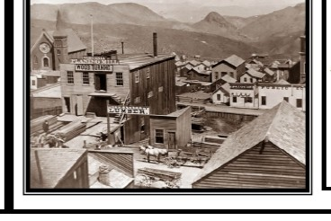How did many saloons, restaurants and hotels/inns start as?

Why do you think the Saloon is an iconic image of the west?

Who worked in these establishments?

What kinds of things were done In the Saloon?

What is th is a pictu re of?

W hat wou ld this become?

